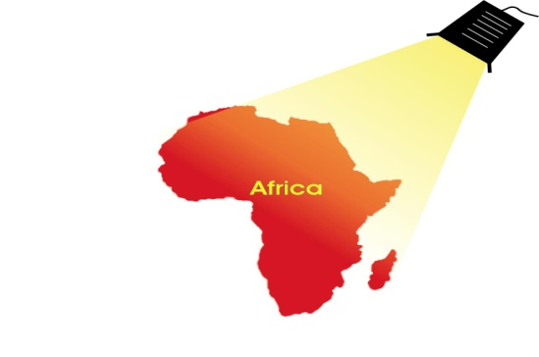
SPOTLIGHT WORKSHOPS & EXHIBITIONS
2014 & 2015 PROGRAMME

|_] 29 & 30 May Harare
Spotlight Travel Workshops (Africa & overseas destinations)
Two sessions Thursday late afternoon Cresta Lodge Harare.
Friday morning Cresta Lodge.
Cost USD 800 / ZAR8800

Karibu Travel Fair Arusha Tanzania 06-08 June

[_]10,12 &13 June Dar es Salaam and Nairobi
Spotlight Travel Workshops (Africa & overseas destinations)
One morning session in DAR ($495/ ZAR5450)
and two morning sessions in Nairobi ($950/ZAR10450)

AIBTM – American Meetings & incentive Exhibition Florida 10-12 June

|_] 22 ,23 & 24 July Rosebank, Johannesburg, Sandton & Cape Town
Spotlight on Africa & Indian Ocean.
Cost ZAR9,900 plus VAT

SAACI Conference St. Lucia KZN August –17-19 August

|_] August Spotlight Lusaka Zambia (date to be confirmed)

IBTM India Chennai 03 -05 September.

|_] 08 -12 SEPTEMBER Spotlight Holland & Scandinavia Nordics Workshops
08 September – Amsterdam - Cost Euro995
09 September - Billund Denmark Cost Euro790
10 September - Copenhagen Denmark Cost Euro850
11 September - Oslo Norway Cost Euro850
Accommodation not included

CIBTM Beijing China 17- 19 September 2013

|_] 18 September Maputo - Spotlight Travel Expo (Africa & Overseas Destinations)
Late afternoon session Cost ZAR6,500 $650

SITE Trade Show Dar es Salaam 02-04 October
Sanganai Zimbabwe Travel Expo Harare 09-11 October
Magical Kenya Expo Nairobi 17-19 October

27-30 October – IGTM - International Golf Travel Market Lake Como Italy

AKWAABA Travel Expo Lagos Nigeria 26-28 October

03-06 November - World Travel Market London

18-20 November - EIBTM Barcelona

[_] 25 - 27 November - Spotlight Eastern Europe workshops
Warsaw Poland; Budapest Hungary; Prague Czech Republic.
Cost Euro3400 plus accommodation

01-04 December ILTM –International Luxury Travel Market Cannes

2015 PROGRAMME

Gaborone 12 & 13 February -Spotlight Travel workshops (Africa & overseas Destinations)
Two sessions –Late afternoon on Thursday and Morning session on Friday. Cost ZAR 5500

Meetings Africa - Sandton - February 24-25

AIME - Asia-Pacific Incentives & Meetings Expo Melbourne 24-25 February 2015
ITB Berlin - 04-08 March

GIBTM – Abu Dhabi – 16-18 March 2015

Easter 03-06 April

AFRICAN TRAVEL WEEK CAPE TOWN
ILTM AFRICA – Cape Town 13-15 April – Cape Town ICC
IBTM Africa 13-15 April – Cape Town ICC
World Travel Market Africa 15-17 April - Cape Town ICC

World Travel Market Latin America Sao Paulo 23-25 April 2015

Arabian Travel Market Dubai 04 - 07 May 2015
Indaba 09-11 May

For more Information:
www.houstonmarketing.co.za
or contact Derek Houston 082 464-0901
derek@houstonmarketing.co.za

Dates are subject to change and prices are provisional.

Booking Form Spotlight Workshops 2014
E-mail or Fax to:
Fax +27 12 6651677
sales@houstonmarketing.co.za Tel +2712 6651191/0824640901

[ ] Please book a table on the following Spotlight workshops
……………………………………………………………………………………………………
……………………………………………………………………………………………………
……………………………………………………………………………………………………
……………………………………………………………………………………………………

[ ] we are interested in participating in the following Spotlight workshops
Please send me more Information
……………………………………………………………………………………………………
……………………………………………………………………………………………………
……………………………………………………………………………………………………
……………………………………………………………………………………………………
COMPANY Name
………………………………………………………………………….....……………………...

CONTACT NAME ....................................................................................................

ADDRESS : ...................................................................................................................

……………………………………………….. Postal Code: ……………….

TELEPHONE : ................................. FAX :………………........

E-MAIL : ................................................................…………………..

derek@houstonmarketing.co.za
www.houstonmarketing.co.za
www.spotlightworkshops.co.za

